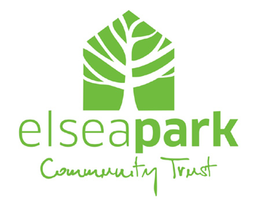
Complaint / Compliment Form

At Elsea Park Community Trust, the Staff and Directors pride themselves on delivering a
high level of service to residents and working with contractors and other parties to ensure mutually
beneficial arrangements are in place.

We understand that there will be occasions where it may be considered that we have not met
our obligations and that a complaint is in order. We take complaints regarding our performance, our staff, and our levels of service very seriously.

If you are not satisfied, please use this form to submit a formal complaint; conversely, the form can be used to give complimentary feedback if appropriate. We aim to acknowledge receipt of a complaint within two working days and to deal with the complaint within twenty working days. If we cannot meet this deadline we will advise you accordingly.

Information we’ll need from you:

- your email address and/or postal address (so we can reply)
- a clear, detailed description of what your complaint is about
- copies of any letters or emails related to the complaint

Please provide your details

First name(s) |  | Title
Surname
Postal Address
(including postcode)
daytime phone |  | Mobile
home phone |  | Email

please indicate to whom your complaint or compliment refers

☐ General ☐ Board Chairperson

☐ Trust Manager ☐ Board Member

☐ Trust Staff Member ☐ Other (please specify)

Please detail the complaint or compliment

In the case of a complaint, please tell us how you think it could be addressed or resolved

You can email the completed form to the Trust Manager at graeme.parrott@elseapark.co.uk

If your complaint regards the Trust Manager, you can send it to the Chairman at jono.brough@elseapark.co.uk.

Alternatively, you can print and post the completed form, marked “Confidential” to:

The Trust Manager or The Trust Chairman
Elsea Park Community Trust
The Centre @ Elsea Park
1 Sandown Drive
Bourne
PE10 0US

